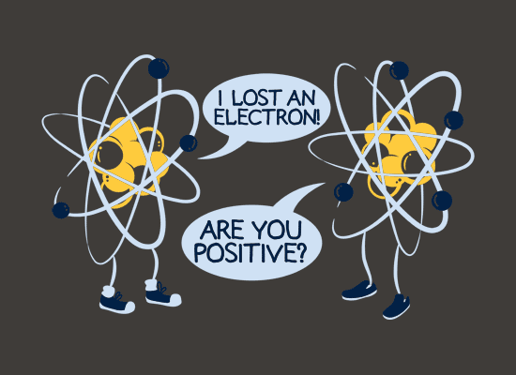
10 Quick Questions
Name: _______________________________

- How would you define the “mass number” of an atom?
- How would you define the “atomic number” of an atom?
- Calcium has the atomic number 20, What is its electron configuration?
- What type of ion do metals form? (Name and Charge)
- What is the difference between molecular compounds and ionic compounds? (Think of as many things as you can)
- Why are the “noble gases” so unreactive?
- Why do we make metal alloys?
- Complete the following:
  - Calcium + Oxygen ______________________
  - Sodium + Water ____________________ + __________________
- Complete the following balanced chemical equations
  - Ca + O₂ ___________
  - Na + H₂O ____________ + _____________
- Define the term “isotope”.

