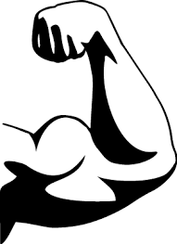
BODYWORKS
10 QUICK QUESTIONS

- What are three main functions of the skeleton?

- Name three different types of joints.

- What is manufactured by the bone marrow?

- What is the name of the large bone of the upper leg?

- What is the medical name for the knee cap?

- If humans have an endoskeleton, what do crustacean have?

- The animal kingdom is splint into what two distinct groups?

- What is the difference between tendons and ligaments?

- What is the name we give to the energy of movement?

- What chemical compound is compact bone made of?

